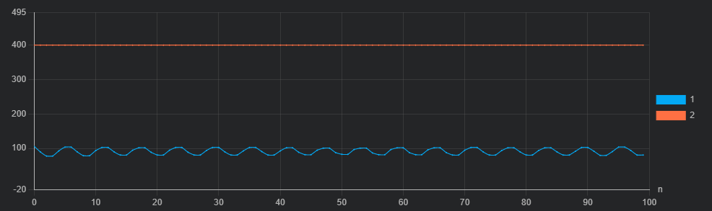

Count -= lastCount

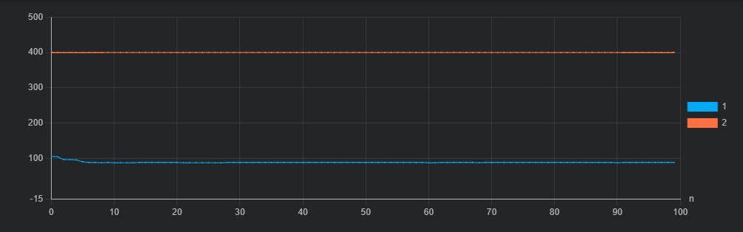

Count = 0